Date:22\10\26
C02-Assessment Tool-1
( ANALYTICAL PROBLEM SOLVING)
Course code:DSA0308
Course Name:Natural Language Processing
Name:P.Varshini
Reg no:192472372
Q-1 Given the input words: “connected”, “connecting”, “connection”, design a
morphological analysis pipeline for a document indexing system.
ANSWER:
CODE:
words = []
for i in range(3):
word = input("Enter a word: ")
words.append(word)

print("\nWord Root Suffix Type Normalized")
print("-" * 75)

for word in words:
if word == "connected":
root, suffix, kind = "connect", "ed", "Inflectional"
elif word == "connecting":
root, suffix, kind = "connect", "ing", "Inflectional"
elif word == "connection":
root, suffix, kind = "connect", "ion", "Derivational"
else:
root, suffix, kind = word, "-", "Unknown"

print(f"{word:<15}{root:<12}{suffix:<12}{kind:<18}{root}")
INPUT:
Enter a word: connected
Enter a word: connecting
Enter a word: connection
OUTPUT:
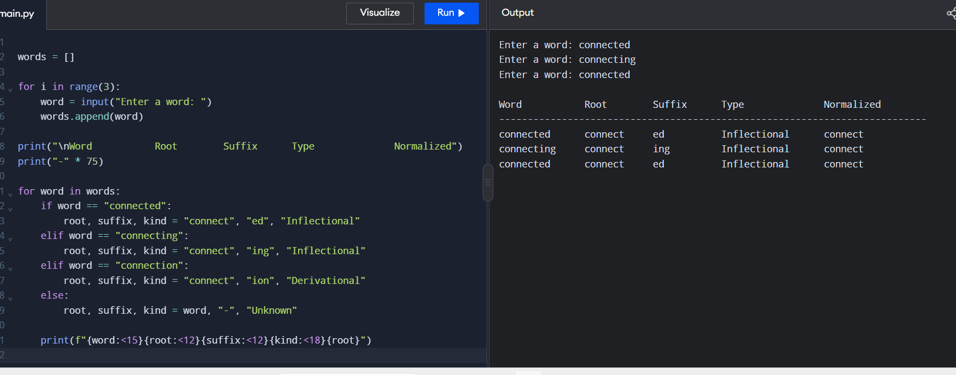
Q-2 2.Given the input words: “unhappy”, “happiness”, “happily”, design a morphological parsing module for sentiment analysis.
ANSWER:
CODE:
words = []

for i in range(3):
words.append(input("Enter a word: "))

print("\nWord Prefix Root Suffix Type Normalized")
print("-" * 75)

for word in words:
if word == "unhappy":
prefix, root, suffix = "un", "happy", "-"
elif word == "happiness":
prefix, root, suffix = "-", "happy", "ness"
elif word == "happily":
prefix, root, suffix = "-", "happy", "ly"
else:
prefix, root, suffix = "-", word, "-"

print(f"{word:<15}{prefix:<10}{root:<10}{suffix:<10}{'Derivational':<14}{root}")

INPUT:
Enter a word: unhappy
Enter a word: hapiness
Enter a word: happily

OUTPUT:

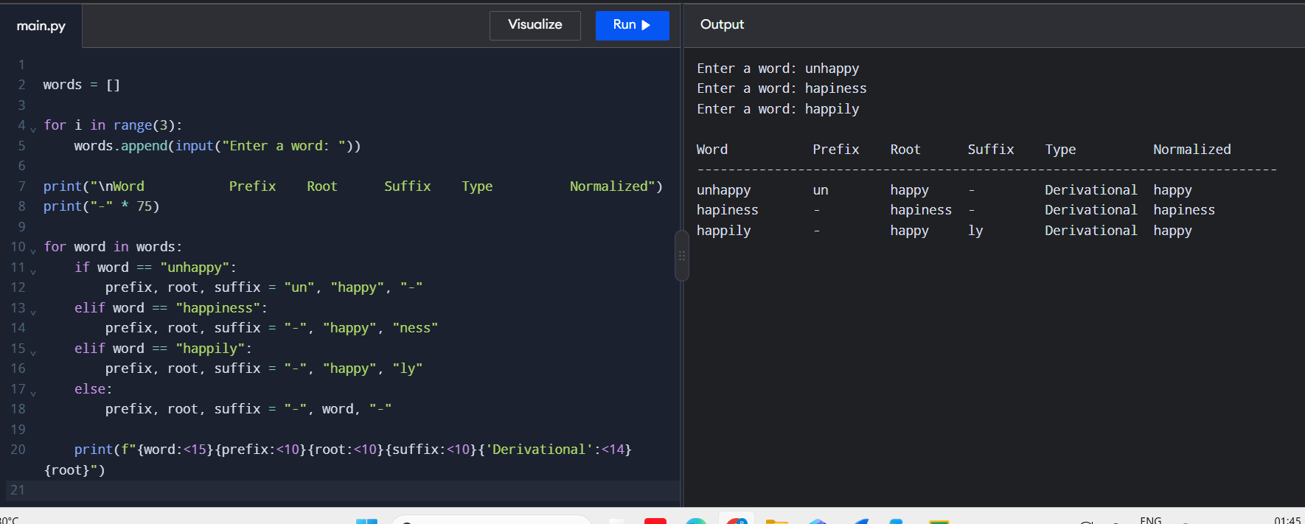
Q3 Given the input words: “played”, “player”, “playing”, design a stemming-based
preprocessing module for a search engine.
ANSWER:
CODE:
words = []

for i in range(3):
words.append(input("Enter a word: "))

print("\nWord Stem Removed Affix Type Normalized")
print("-" * 70)

for word in words:
if word == "played":
stem, affix, kind = "play", "ed", "Inflectional"
elif word == "player":
stem, affix, kind = "play", "er", "Derivational"
elif word == "playing":
stem, affix, kind = "play", "ing", "Inflectional"
else:
stem, affix, kind = word, "-", "Unknown"
print(f"{word:<12}{stem:<12}{affix:<15}{kind:<18}{stem}")

INPUT:
Enter a word: played
Enter a word: player
Enter a word: playing
OUTPUT:
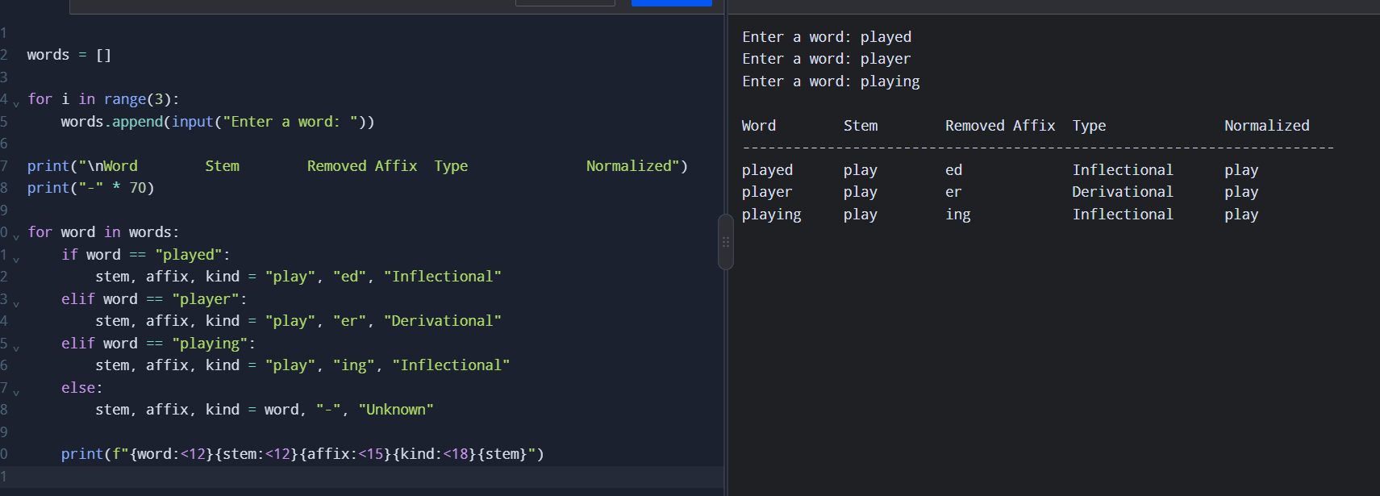
Q4 Given the input words: “writes”, “writing”, “written”, design a finite-state morphological parsing module for a text processing system.
ANSWER:
CODE:
words = []

for i in range(3):
words.append(input("Enter a word: "))
forms = {
"writes": ("write", "write + s", "Regular"),
"writing": ("write", "write + ing", "Regular"),
"written": ("write", "writ + ten", "Irregular")
}
print("\nWord State Path Breakdown Type Root")
print("-" * 85)
for word in words:
if word in forms:
root, breakdown, kind = forms[word]
path = "START -> CHECK -> MATCH -> ACCEPT"
print(f"{word:<11}{path:<36}{breakdown:<15}{kind:<11}{root}")
else:
print(word, "Rejected")
INPUT:
Enter a word: writes
Enter a word: writing
Enter a word: written
OUTPUT:
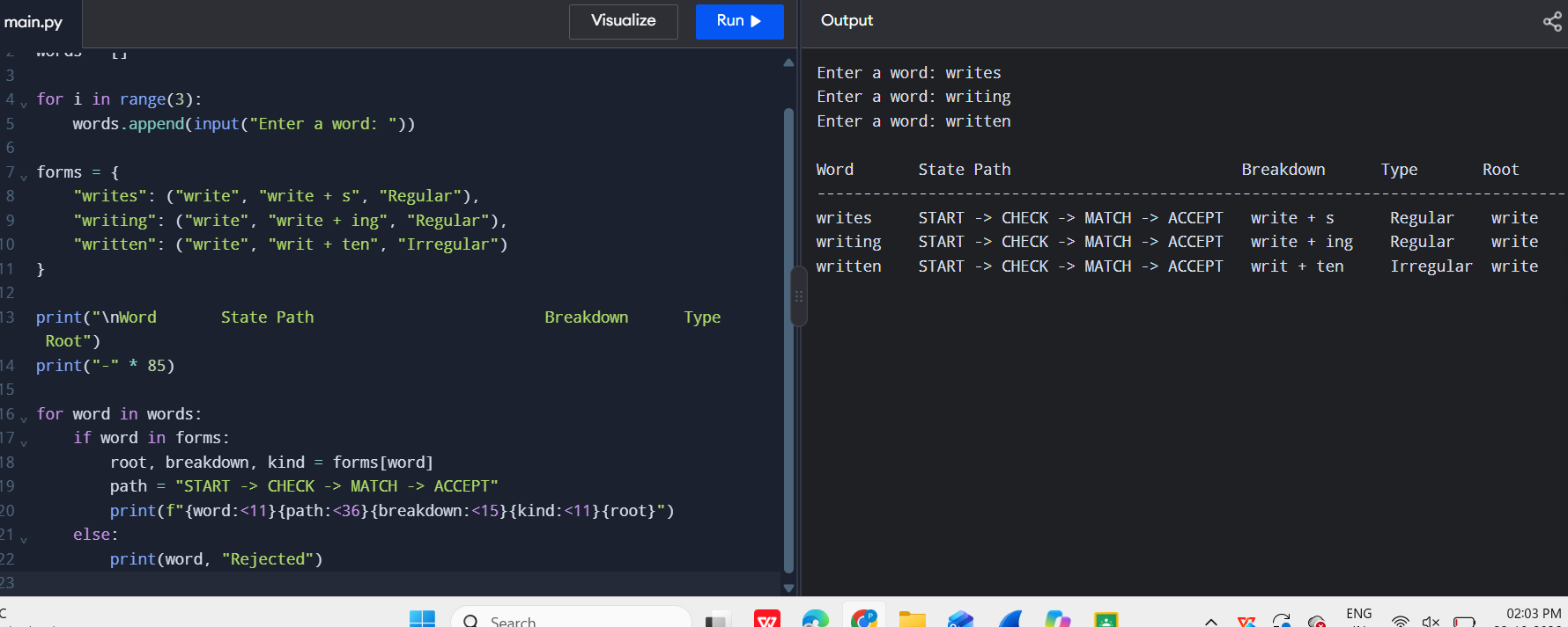
Q5 Given the input words: “relational”, “relation”, “relate”, design a Porter Stemmer-based preprocessing module for document retrieval.
ANSWER:
CODE:
from nltk.stem import PorterStemmer
stemmer = PorterStemmer()
for i in range(3):
word = input("Enter a word: ")
stem = stemmer.stem(word)
print("Original Word:", word)
print("Final Stem:", stem)
print()
INPUT:
relational
relation
Relate
OUTPUT:
